National Defense University
Fort Lesley J. McNair, Washington D.C.
The National Defense University is located on the grounds of historical Fort Lesley J. McNair in Southwest Washington, D.C., between the Anacostia River and the Washington Channel and near the Waterfront Marina, Arena Stage, and Waterside Mall (currently under construction).
The Main Gate is open 0600-1700, Monday through Friday, closed on Federal Holidays. The Visitors Gate (2d Street) is open 24 hours. The Pedestrian Gate near the Coast Guard Headquarters Building and at the end of 2d Street is open Monday through Friday, 0600-1800, closed on Federal Holidays. Photo identification is required at all gates. Pedestrians can access Fort McNair through the main gate with proper photo identification.
Map of Fort McNair
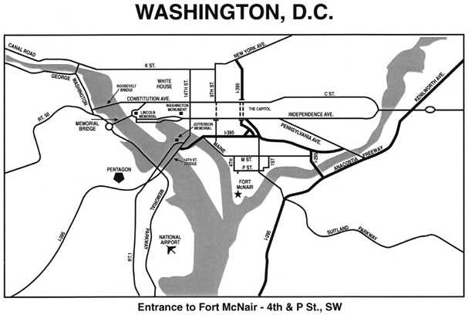

Travel Directions
DIRECTIONS/PARKING: Specific directions to Ft. McNair can be found at: http://www.ndu.edu/info/visitingNDU.cfm

- Consider Metro. It is about a mile to walk. It is safe if you stick to 4th Street which is a straight shot into the base. Here’s metro information from our website:
- If you do not have a DOD sticker on your vehicle, you will have to come through the visitor’s gate on 2nd Street. The gate is right after you make the turn onto 2nd Street. The security personnel will search your car. This is the same gate you will enter if you take a cab.
- If you have a DOD sticker on your vehicle, you can come through the main entrance on “P” street.
- You will need a picture ID (driver’s license, military/government ID).
- Parking is a premium on Ft. McNair. If you get here early enough, there is parking in the small lot near Marshall Hall. You can park in the area near the swimming pool but avoid the reserved parking spots. Your best bet is to use the large parking lot adjacent to Lincoln Hall or the parking lots near the National War College just past the Industrial College of the Armed Forces (Bldg 59).
- The speed limit on Ft McNair is 15 mph so be careful and watch for pedestrians and runners along the street.
Via METRO: Fort McNair is located about one-half mile from the Washington Metro’s Waterfront station on the Green Line. Leaving the station, cross Maine Avenue and walk south down 4th Street for three blocks until it ends and, turning left, becomes P Street SW. The Fort McNair main gate will be plainly visible on the immediate right.
From Virginia(West) via I-66: Follow Route 66 toward Washington, D.C., and take the Independence Avenue exit which goes along the Tidal Basin. Follow the signs for Maine Avenue. Stay straight on Maine; the waterfront and fish market are on your right. Maine Avenue becomes M Street near Arena Stage which is on the left. Turn right on 4th Street (Metro and Waterside Mall is on the left) and continue two blocks until it ends and becomes P Street SW. Immediately after turning left on P Street, the Fort McNair main gate will be plainly visible on the right. Visitors must enter Fort McNair through the 2d Street gate which is two blocks down from the main gate, turn right on 2d Street, and the gate is on the right.
From Alexandria or Maryland via Woodrow Wilson Bridge: On the Maryland side of the Wilson Bridge, take Route 295 north towards Washington, D.C. Exit at South Capitol Street. Go over the bridge, staying in the right lane. Bear to the right at the Nationals Stadium, avoiding the underpass, and turn left on to M Street at the light onto M Street (this takes you over South Capitol Street). Turn left at the light on 2d Street to go to the visitors gate or left at the light at 4th Street to go the main gate.
From Maryland: Follow the Capitol Beltway (I-495 or I-95) to the Baltimore-Washington (B-W) Parkway exit. Proceed Southbound on the B-W Parkway. As you near Washington, the B-W Parkway will become I-295 South, turning to the left. Continue on I-295 to the Suitland Parkway exit. Exit at the Suitland Parkway and then immediately exit on to I-295 Northbound. After joining I-295 North, immediately exit at the South Capitol Street exit. Proceed across the South Capitol Street Bridge, staying to the right. Bear right coming off the bridge (at the Nationals Stadium), avoiding the underpass, and turn left on to M Street SW at the traffic light. Turn left at the light on 2d Street to go to the visitors gate or left at the light at 4th Street to go the main gate.
From Northwest D.C.: From Constitution Avenue, going east towards the Capitol, turn right on 7th Street which will bring you to Maine Avenue (Waterfront is straight ahead). Turn left on Maine Avenue at the traffic light. Follow Maine Avenue which becomes M Street near Arena Stage on the left. Turn right on 4th Street (Metro and Waterside Mall is on the left) and continue two blocks until it ends and becomes P Street SW. Immediately after turning left on P Street, the Fort McNair main gate will be plainly visible on the right. Visitors must enter Fort McNair through the 2d Street gate which is two blocks down from the main gate, turn right on 2d Street, and the gate is on the right.

http://www.ndu.edu/irmc

